**Model results**

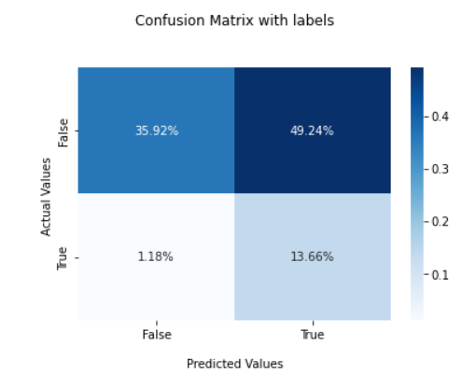**Naïve Bayes**

**Accuracy:** 0.4856661045531197

**K- Nearest Neighbour**

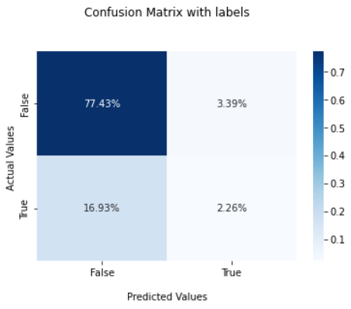

**Accuracy :** 0.7968397291196389

**Decision Tree**

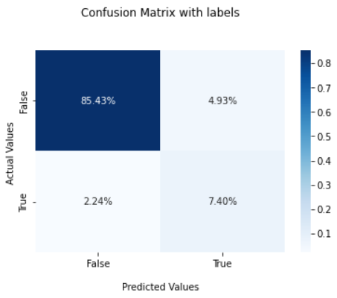

**Accuracy:** 0.9282511210762332

**Random Forest**

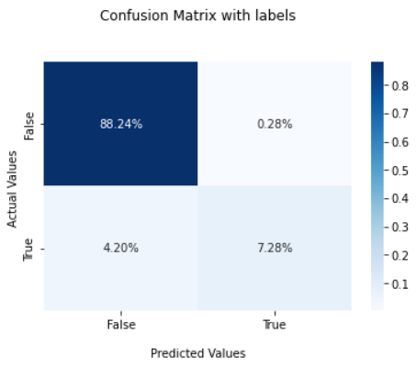

**Accuracy:** 0.9410112359550562

**Logistic Regression**

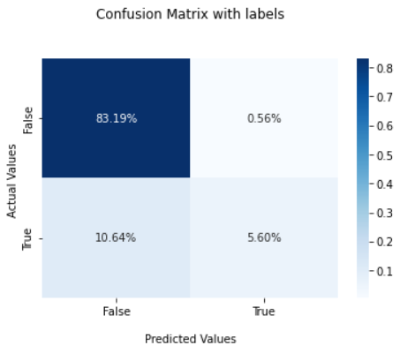

**Accuracy:** 0.8879551820728291

**SVM**

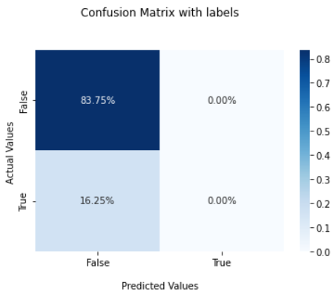

**Accuracy:** 0.8375350140056023

**Final Metrics**

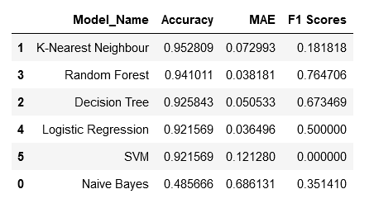

**Recommended model:** Random Forest